LCD Receiver Build

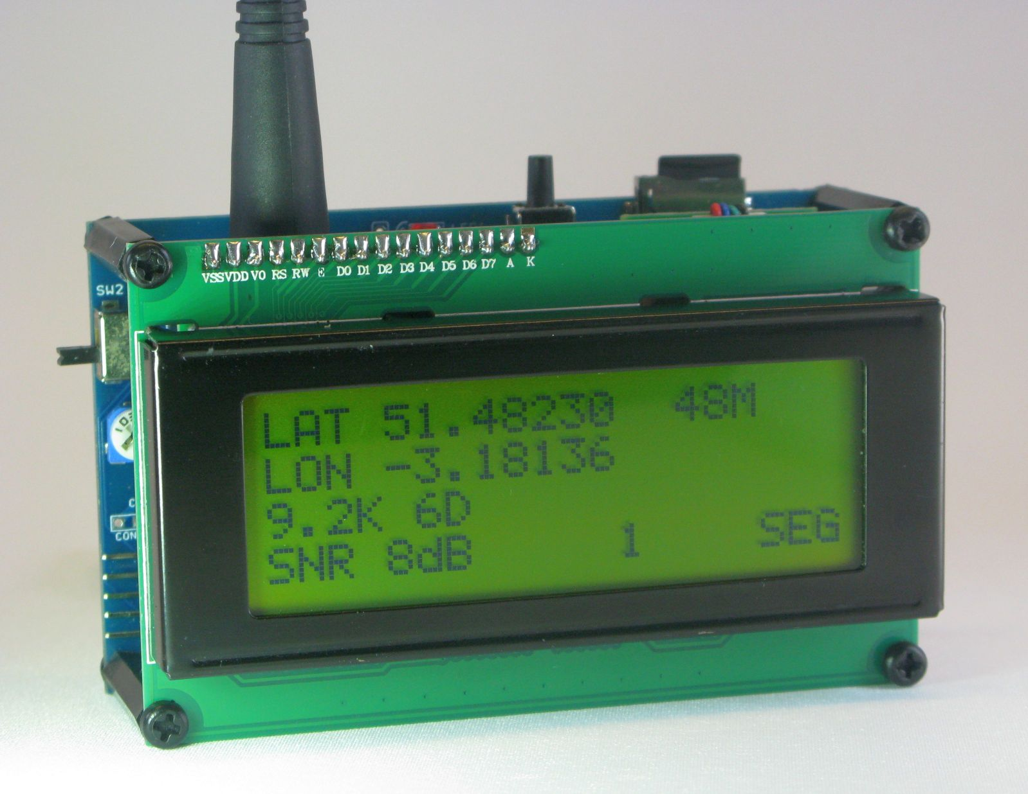

Table of Contents
Introduction 4
What is LoRa? 5
Bandwidth 5
Spreading Factor 6
Coding Rate 6
How the LoRa settings affect range 6
Skills Required to Build Receiver 7
The Arduino Environment 7
Programming Adapters 7
Test Programs 8
Building the Receiver 9
Check the Receiver PCB 9
Fit the Arduino Pro Mini 9
Fitting the Mikrobus Sockets 10
Building the LoRa Mikrobus module 11
Dorji DRF127xF 11
Fitting the DRF1272F 11
Fitting the DRF1278F 12
RFM9x 13
Testing the LoRa module 14
Building the GPS Mikrobus module 16
Assembling a Global Top GPS module 16
Assembling a Ublox GPS module 16
Adding the Battery 18
Testing the GPS 19
Adding the LCD Display 20
Testing the LCD Display 21
I2C FRAM 22
Screen Switch 23
LCD Backlight 23
Decoupling Capacitors 23
Fitting the Display 23
Power Consumption 24
Receiver Options 25
Micro SD Card 25
Low Drop Out Voltage regulator 26
Voltage Overload Diode 27
GPS Power down 27
Bluetooth Adapter 27

Before asking questions about the assembly, parts or programs for the LCD Receiver, please read through these instructions, your question has probably already been answered.

Introduction

The LCD receiver PCB is deigned to be used to build a bench or field portable LoRa receiver. A 20 character x 4 row LCD display mounts on pillars above the board. The transflective form of these displays are ideal for outdoor use being highly visible in bright sunlight.

These 20x4 LCD displays are readily available and are based on the HD44870 controller, this receiver will only work with the 3.3V versions of the display. These displays have an 8 bit data bus and 3 control lines, but it can also be driven in 4 bit mode. The 7 bits required can be provided with a PC8574 I2C 8 bit I\O expander. There is an Arduino library designed to drive these LCDs with a PC8574 via a 4 wire interface, 2 power lines and 2 I2C lines.

Backpack PCBs with the PC8574 device already fitted and designed to be soldered onto the LCDs connector are available at low cost, these backpack PCBs have a 4 pin connector for the I2C interface.

Other types of display, such as OLEDs or TFT types could be fitted to the receiver and driven via the I2C connector direct of via the separate I2C display backpack, but these displays whilst fine for desktop use are close to useless in bright sunlight, you can barely read them.

When assembled the LCD receiver’s switches, LED and LoRa antenna are accessible from the top and sides, the intention being to allow a simple box to be built out of lite ply.

The LCD receiver uses a humble Pro Mini as the Microcontroller, a future PCB will utilise an ATmega 1284P in the same form factor. There is provision on the board for a low drop out regulator set-up, for circumstances where the Pro Minis own regulator is unable to provide the required current.

Rather than dedicate the board for a particular LoRa device and GPS, the board has two Mikrobus sockets, one on the right primarily for the LoRa module, the other on the left for the GPS. The use of the Mikrobus sockets adds considerable flexibility, there are Mikrobus PCBs for the Hope RFM9x and Dorji DRF127x LoRa modules and another Mikrobus PCB that will take a range of GPSs. The PCB has provision for fitting a MicroSD socket and there is a version of the LoRa receiver program that allows the receiver to be used as a telemetry logger.

The Mikrobus sockets could of course be used for other purposes and Mikroelectronica do a large range of suitable modules. Do note that because of the limited I\O pins available on an Arduino Pro Mini not all defined Mikrobus pins are available on each socket. See the circuit diagram for details.

Whilst these instructions concentrate on building the receiver with the Mikrobus modules fitting in sockets on the PCB, it is possible to build a receiver around 10mm thinner by fitting the Mikrobus modules direct to the PCB, but do read the comments later in the instructions if you want to use the SD card or external GPS connections that are underneath Mikrobus socket 2. Also review the comments about wiring the LCD display later in these instructions.
The build instructions will concentrate on building a minimum component count receiver, with details of other build options at the end of this document. Initially the bare PCBs will be available for sale, but shortly a kit should be available that allows a bare bones receiver to be built. This kit will not contain items such as the Arduino Pro Mini, GPS, display or battery as I cannot supply these parts at prices the DIY constructor would find acceptable.

What is LoRa?
LoRa is a type of chirp spread spectrum transmission and has been implemented by Semtech for use in low cost ISM band devices.

For a normal FSK style transceiver (such as the Hope RFM22B) the receiver needs to see signal that is strong enough to be greater than the local RF noise level. Noise levels in the ISM bands are a performance limiter and each device in use adds to the local RF noise level. The total noise a receiver sees is a combination of local RF noise and noise generated by the electronics inside the receiver.

Assume a typical FSK transceiver needs to see a signal that is 5dB above the receiver’s noise level in order to decode it. In comparison LoRa technology allows for signals to be received that are as much as 20dB below noise level, thus the LoRa signal can be up to 25dB (5dB + 20dB) weaker than the FSK one and still be received. If LoRa can decode a signal that is 25dB weaker, then the transmitter can be further away than in the FSK example. If you double the distance that a transmitter is away from the receiver then the receiver will see signals that are 6dB weaker, thus the 25dB difference equates to a distance difference of approximately 17 times.

So due in the main to the below noise level performance of LoRa it is able to receive signals that are much weaker and thus much further away than with some previous ISM band modules.

LoRa modules are straight forward to drive and very flexible, the internal firmware takes care of all internal adjustments and optimisations. The parameters that need to be configured for LoRa are, Spreading Factor, Coding Rate, Bandwidth and transmit power. These parameters can be easily changed so that you can set-up for low data rate long range or high data rate shorter range.

LoRa is also a two way technology, the tracker transmitter is a receiver too, so if you can pick-up signals from your tracker you can send it commands or exchange data with it also.

Bandwidth
We first need to consider the impact of the bandwidth setting. The LoRa bandwidth is the amount of frequency spread the signal occupies. The bandwidths LoRa can be set to are;
7.8Khz, 10.4Khz, 15.6Khz, 20.8Khz, 31.25Khz, 41.7Khz, 62.5Khz, 125Khz, 250Khz, 500Khz.

A low bandwidth signal, such as 7.8Khz will give the best (longest distance) performance, but with the low cost components used in the Hope and Dorji modules a transmitter and receiver may not talk to each other at this bandwidth. The receiver has a capture range, this is the percentage difference allowable in relation to the bandwidth that the transmitter and receiver can be apart in frequency in order for the receiver to pick up the transmitters signal. This percentage is typical 25% of the bandwidth.

Lets assume the bandwidth in use is 10Khz, the allowable variation is 25% or 2.5Khz and the transmitter is on 434.000Mhz. For the link to work the receiver needs to be on or between 433.9975Mhz and 434.0025Mhz. This is an exacting requirement for a low cost crystal, even if transmitter and receiver are at the same temperature.

Low bandwidths of 20.8Khz have been used for tracking and they do give better performance, but care is needed as devices used at this bandwidth may not talk to each other unless a calibration factor is measured and applied.

A bandwidth of 62.5KHz has been found to be reliable and allows for differences in manufacturing tolerance and temperature between transmitter and receiver devices.

Spreading Factor
This controls the amount of signal processing gain. The spreading factor can be set between 6 and 12. A setting of 6 can only be used with fixed length packets, so has not been used in my applications.

The spreading factor defines the below noise performance. SF6 gives a -7.5dB below noise performance and SF12 a -20dB below noise performance.

The larger spreading factors therefore give more range, the trade off is that higher spreading factor packets take longer to transmit.

Coding Rate
Additional data can be added to the packet to allow for error correction. This can result in small signal gains at the limit of reception. The coding rate can be varied between 4:5 and 4:8, the higher 4:8 rate will result in longer packets.

A fuller description of LoRa will be found in this document;

http://www.semtech.com/images/datasheet/an1200.22.pdf

How the LoRa settings affect range
Having established a practical LoRa bandwidth, 62.5KHZ for a tracker, we can use this to look at how the spreading factor affects range and the time to transmit a typical 20 byte GPS location payload.

The lower spreading factors will give the highest data rates and the shortest packets in time terms, in turn this is more battery efficient. The lowest spreading factor we will consider is 7.

Now, assume we are using a bandwidth of 62.5KHZ and a spreading factor of 7, that will give an equivalent data rate of 2734bps, according Semtech's 'Lora Calculator' tool. The time taken to transmit our 20 bytes is 98mS. Assume that is our base and that in a typical urban area the limit of reception is 500m. To find a 'lost' model you would need to explore an area on a 1km grid, so that you are always within 500m of the 'lost' model.

If we switch to spreading factor 12 then the data rate drops to 146bps and the transmit time goes up to 2.2 seconds so this is a slow packet. The benefit of the higher spreading factor (and longer transmit time) is significant, we now have an approximate 14dB of extra signal gain. This is equivalent to 5 times further range, so our 500M now extends to 2.5km and the search grid is now strips 5km apart.

Now 5 times longer distance may not seem a lot, but appreciate how much difference it can make to the transmit power required to cover the extra distance. If we were transmitting at 10mW and that gave us the 500m range, to cover 5 times further range just by increasing transmit power would require a transmitter putting out 25 times the 10mW (250mW) and a very much larger battery..

Skills Required to Build Receiver
Although this project does not require refined surface mount soldering skills, the LCD receiver does need care in assembly and it is not going to be a suitable project for a relative newcomer to soldering.

The Arduino Environment
A basic level of knowledge and experience in using the Arduino environment is required to be able to build and construct the transmitter and receiver. You will need to understand the basics of program flow and how to make changes to the programs. There are numerous Arduino tutorials available on the Internet. You will need experience of downloading and installing 3rd party software libraries.

The programs were tested against a fresh download of the latest Arduino IDE, 1.8.5 at the time of writing. Most of the libraries used in the programs are part of the standard install, additional libraries you may need to download and install for the various programs for the LCD receiver are listed below.

TinyGPS++ - http://arduiniana.org/libraries/tinygpsplus/
NeoSWSerial - https://github.com/SlashDevin/NeoSWSerial
SendOnlySoftwareSerial - http://gammon.com.au/Arduino/SendOnlySoftwareSerial.zip
LoRaTracker Library - https://github.com/LoRaTracker/LoRaTracker-Library
LiquidCrystal_I2C.h - https://bitbucket.org/fmalpartida/new-liquidcrystal/downloads/ (version 1.3.4)

Programming Adapters
For this project you will need to have a USB serial programming adapter and its driver installed and working on your PC. A typical adapter is shown below;

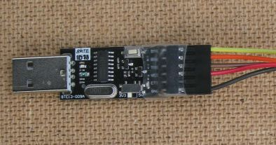

Important: The serial adapter must be the type that has a 3.3V output on the adapters VCC pin !! Some serial adapters are supplied as 5V only, these must not be used.

A programming adapter with a 5V VCC output will damage the LoRa device on the tracker and possibly fry the GPS as well. Some adapters have a switch for 5V\3.3V operation, others have a solder bridge on the bottom of the PCB, make sure these switch-able adapters are set to 3.3V mode.

I use two separate USB serial programming adapters. The top one in the picture below is wired up with the VCC (3.3V) line from the programming adapter not connected to the VCC pin on the Arduino Pro Mini. This is the adapter I use when the tracker transmitter and receiver have a battery connected and avoids a conflict between the VCC from the program adapter and the VCC from the Pro Mini regulator, see picture below.

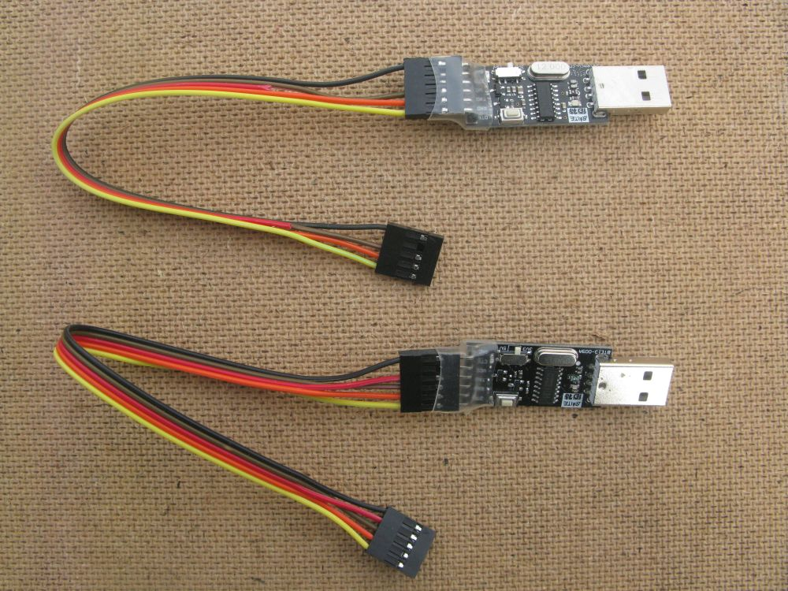

The bottom adapter in the picture has the VCC wire (the red one) connected. This adapter is used when I don’t have a battery or external supply connected to the transmitter or receiver, the tracker is then powered from the program adapter, this is useful for testing.
The tracker programs continuously send diagnostic messages to the Serial Monitor, these messages will tell what the program is doing, what’s happening with the GPS etc. So before assuming there is a fault with the hardware or the program, take a look at what the diagnostic messages say.

Do not have the programming adapters connected to the receiver PCB when you are soldering or adding components.

Test Programs
Several of the test programs mentioned in these instructions need to be changed to allow the correct board definition file to be loaded. The board definition file is part of the LoRaTracker library and contains the pin definitions for the test programs and completed receiver. The test programs will have a series of lines such as this at the top of the listing;

//#include "Locator2_Board_Definitions.h"
//#include "LCD_Receiver_Board_Definitions.h"
//#include "Relay1_Board_Definitions.h"

To ensure the required ‘LCD_Receiver_Board_Definitions.h’ file is loaded, remove the two // characters at the beginning of the appropriate line so it looks like this;

#include "LCD_Receiver_Board_Definitions.h"

The Test programs will be found in the Test-Programs repository;

https://github.com/LoRaTracker/Test-Programs

Building the Receiver
OK, we are ready to start the build. Please read through all the build instructions from beginning to end before turning on your soldering iron. Some items and options need to be assembled in a particular order, so to be sure you don’t miss anything read through all the instructions first.

Check the Receiver PCB

First give the PCB a thorough visual check, look for breaks in tracks or shorts. Then using a multimeter, check for shorts between pins and then check against the circuit diagram that the connections (pins) that should exist check out with a continuity tester. These tests might well be seen as very tedious, but they are important. The supplied boards are checked in manufacture and if faulty will of course be replaced. However, the replacement will not extend to replacing each part that my have been fitted to the PCB.

Fit the Arduino Pro Mini

Solder in place the Arduino Pro Mini using 0.1” pin headers.

You will need 2 off 12 pin, 2 off 2 pin, and 1 off 6 pin straight 0.1” header pins. Do not forget to fit the 2 off 2 pin headers above and below the processor that are the A4, A5, A6 and A7 connections.

Important: The Pro Mini must be a 3.3V 8Mhz type and check that the pin layout matches the receiver PCB and the 6 pin programming connector on the end away from the reset switch. There are a few different layouts for the Pro Mini, so be sure to get the right one.

Solder in place the 5 way 0.1” angled connector that will be the programming connection.

Use a 5 pin lead between the USB program adapter and the LCD receiver board, this lead will provide a temporary source of power to the receiver board for our initial tests. See the comments on serial adapters above.

Load the ‘LED_Blink_Test’ sketch\program in the LCD Receiver program directory, this is program will flash the Pro Mini pin 13 LED very quickly, so you can tell the difference from the standard Blink program that the Pro Mini may have been supplied with.

Solder in place LED1 and R1 on the Receiver PCB

Connect the program lead to power the receiver and check the receiver LED flashes.
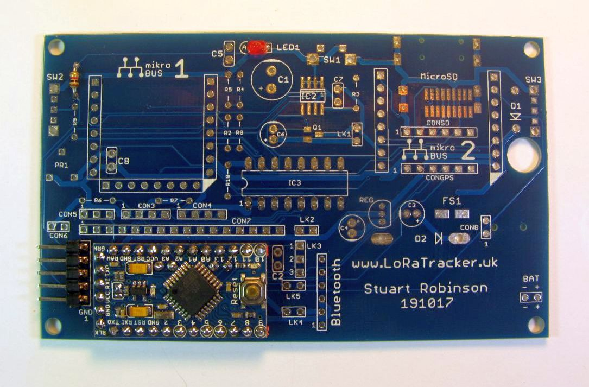

If you intend to fit the optional components for turning off the power to Mikrobus socket 2 (GPS typically) then its best to fit them now, see the section ‘Receiver Options’ and ‘GPS Power down’ later in these instructions.

You can use 0.1” socket headers for the Mikrobus sockets and although this adds about 10mm to the thickness of the completed receiver, it does mean you can easily swap Mikrobus modules between projects or replace faulty ones. Once a Mikrobus module has been tested, you can solder it directly to the PCB for a thinner and more robust receiver. If your going to solder the Mikrobus modules direct to the PCB, see the comments later in these instruction on fitting the MicroSD card socket and external GPS connector. The choice is yours.

Fitting the Mikrobus Sockets

Solder in place the 8 pin 0.1” header sockets, 5 of them, for Mikrobus module sockets 1 and 2.

Mikrobus socket 1 is a slightly modified Mikrobus in that it has an extra 8 pin connector at the bottom. This is to allow for two interrupts on the LoRa device to be available which is needed for some applications. The standard Mikrobus modules will still fit.
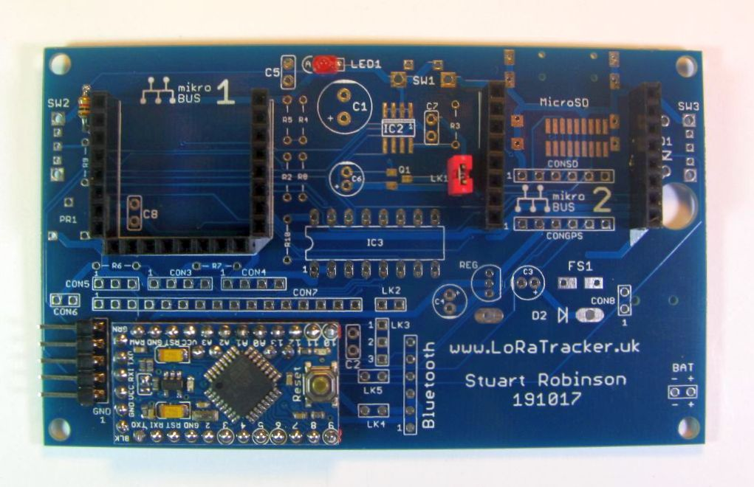

Building the LoRa Mikrobus module

You will need to build one LoRa Mikrobus module, there are PCBs for both the Dorji DRF127x and Hope RFM9x LoRa devices. Build instructions for both are provided here.

Mikrobus Dorji DRF127xF
This Mikrobus board is for a Dorji DRF1272F(868Mhz) or DRF1278F (433Mhz) LoRa modules.
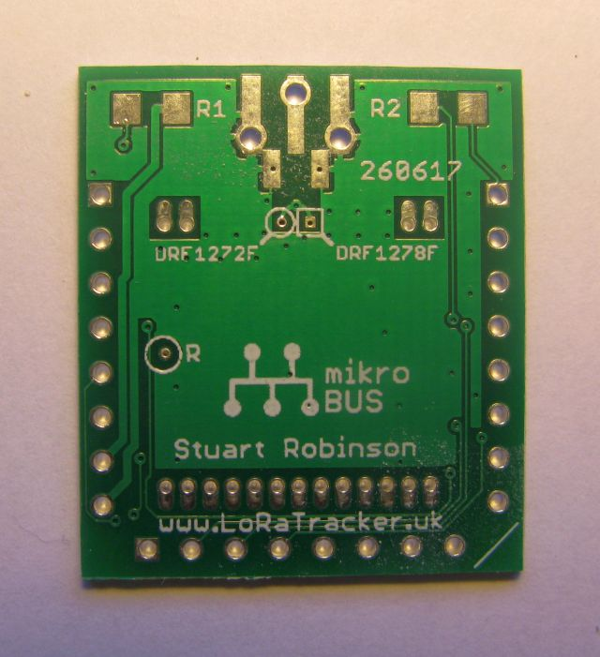
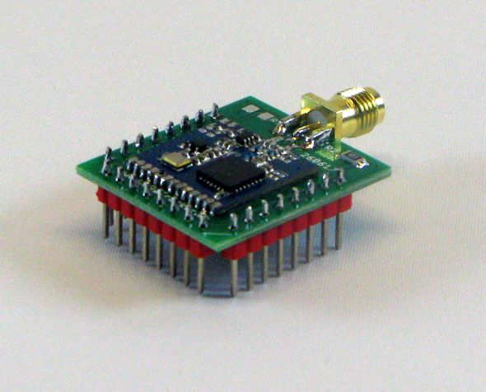

The connection to the RESET pin on the LoRa module can be left open circuit as the LoRa device has an internal pull up on this pin. Most of the LoRaTracker programs do use this pin however to reset the LoRa device on a regular basis. If you want to be sure that the RST pin on the Mikrobus socket is not connected to the LoRa device RESET then drill through the via (pad) labelled ‘R’ and circled on the top of the PCB before fitting the LoRa device. This will cut the track to the LoRa devices RESET pin.

This Mikrobus board will fit in a standard Mikrobus socket but some of the possible LoRaTracker programs and boards need access to more of the LoRa devices DIO pins than the standard Mikrobus layout socket allows. All the LoRa device DIO pins are made available by using an extra 8pin header at the bottom of the Mikrobus board. See the schematic for details.

This Mikrobus board is ‘breadboard’ friendly if you only fit use the two 8way pin headers on the sides.

The Dorji LoRa module can be soldered to the PCB as a surface mount device or slightly easier using one 13way 0.05” pin headers for the logic pins and a 2way 0.05” pin header for the antenna.

Important: The DRF1272F (868Mhz) and DRF1278F (433Mhz) have different pin outs, the antenna connections are on different sides. The Mikrobus PCB can be used with both modules but you do need to drill out or cut a track before fitting the LoRa module, this is described below.

Fitting the DRF1272F

If your using this module (the 868Mhz one) then you need to cut the track that comes from the antenna pin for the DFR1278F. Assuming the board is viewed with the SMA antenna connection upwards, the antenna connection for the DRF1278F is on the left, and this need to be disconnected. There is a via (pad) marked with a circle and DRF1272F you need to drill through this pad or cut the track. See picture below of before and after detail;

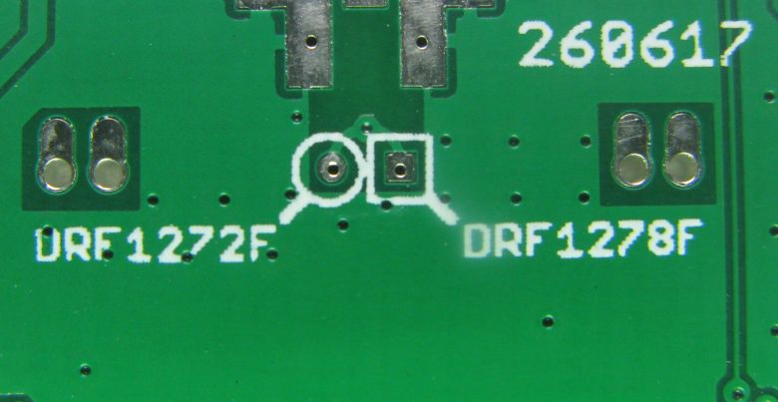
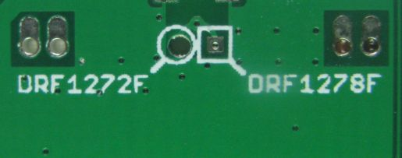

Fitting the DRF1278F

If your using this module (the 434 Mhz one) then you need to cut the track that comes from the antenna pin for the DFR1272F. Assuming the board is viewed with the SMA antenna connection upwards, the antenna connection for the DRF1272F is on the right, and this need to be disconnected. There is a via (pad) marked with a circle and DRF1278F, you need to drill through this pad or cut the track. See picture below before and after detail;

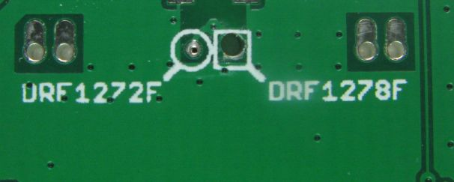

Once the LoRa device is soldered in place you can add the 3 x 8way 0.1” pin headers on the sides and bottom of the Mikrobus board. Make sure the pins are straight, its easier if the board is temporarily placed in a Mikrobus socket for soldering.

R2 (10K) should be fitted if your going to use the LoRa device with the LoRaTracker programs which send FM audio tones. The resistor protects DIO2 on the LoRa module when its an output and is then (accidentally) connected to the PWM output pin of the Mikrobus socket. If you want to access DIO2 for other purposes then either fit a very low or zero ohm resistor for R2 or bridge it with solder or wire.

The antenna connection can either be an edge SMA, U.FL socket or indeed a bit of wire of the correct length. There are also holes that will allow a through hole type SMA socket to be fitted.

Important: Do not operate the LoRa device without an antenna as the LoRa device can easily be damaged in this way.

Mikrobus RFM9x

This Mikrobus is the board is for a Hope RFM9x, there are versions of this module for 433MHz, 868Mhz and 915Mhz, all have the same pin out.

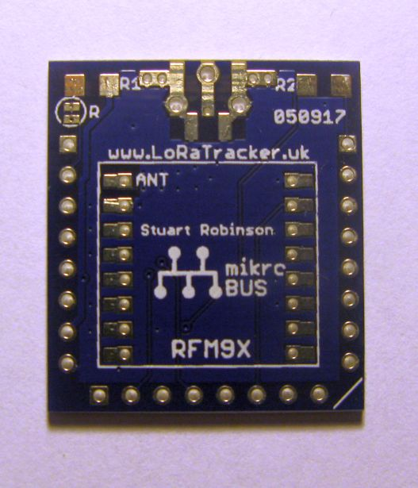
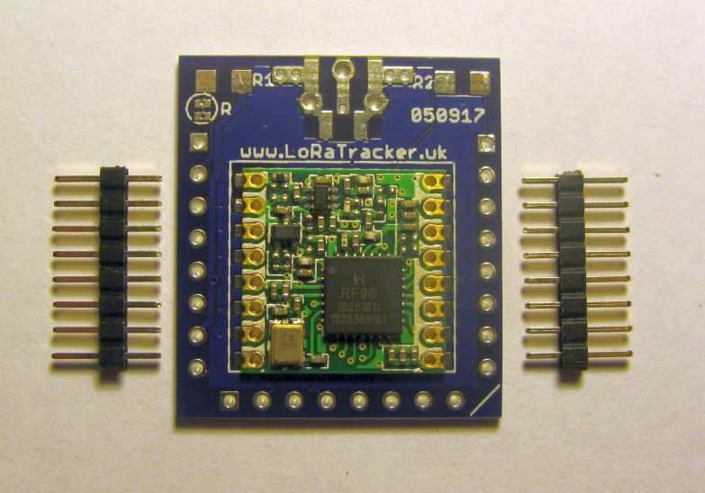
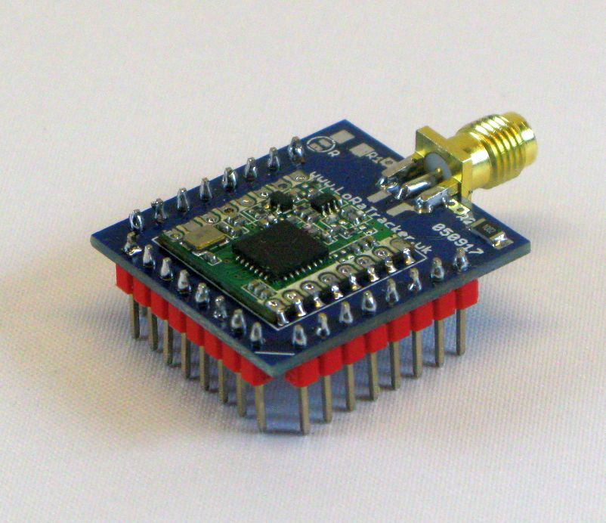

This Mikrobus board will fit in a standard Mikrobus socket but some of the possible LoRaTracker programs and boards need access to more of the LoRa devices DIO pins than the standard Mikrobus layout socket allows. All the LoRa device DIO pins are made available by using an extra 8pin header at the bottom of the Mikrobus board. See the schematic for details.

This Mikrobus board is ‘breadboard’ friendly if you only fit use the two 8way pin headers on the sides. There is a different version of this PCB that uses 10way pin headers on the sides so that the LoRa devices DIO1, DIO3, DIO4 and DIO5 pins are available when the module is plugged into a breadboard.

The LoRa module can be soldered to the PCB as a surface mount device or slightly easier using 2 x 8way 2.00mm pin headers. See the pictures for the correct orientation of the RFM9x module.

Once the LoRa device is soldered in place you can add the 3 x 8way 0.1” pin headers on the sides of the Mikrobus board. Make sure the pins are straight, its easier if the board is temporarily placed in a Mikrobus socket to hold it steady.

The connection to the RESET pin on the LoRa module can be left open circuit as the LoRa device has an internal pull up on this pin. Most of the LoRaTracker programs do use this pin however to reset the LoRa device on a regular basis. If you want to be sure that the RST pin on the Mikrobus socket is not connected to the LoRa device cut the track that connects the two halves of LKR.

R2 should be fitted if your going to use the LoRa device for sending tones as it protects DIO2 when its and output and is then connected to the PWM pin of the Mikrobus socket of when it also is an output. If you want to access DIO2 for other purposes then either fit a very low or zero ohm resistor for R2 or bridge it with solder or wire.

The antenna connection can either be an edge SMA, U.FL socket or indeed a bit of wire of the correct length. There are also holes that will allow a through hole type SMA socket to be fitted, see pictures.

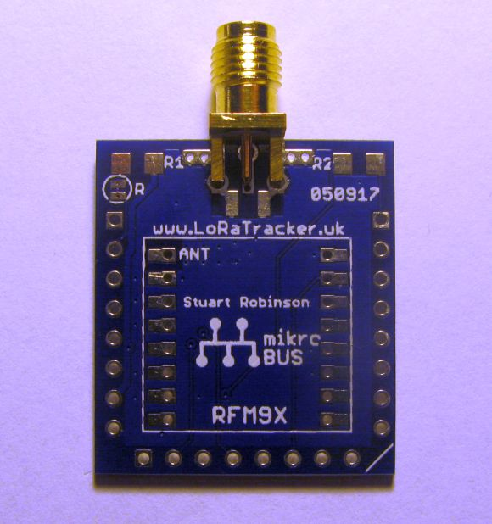
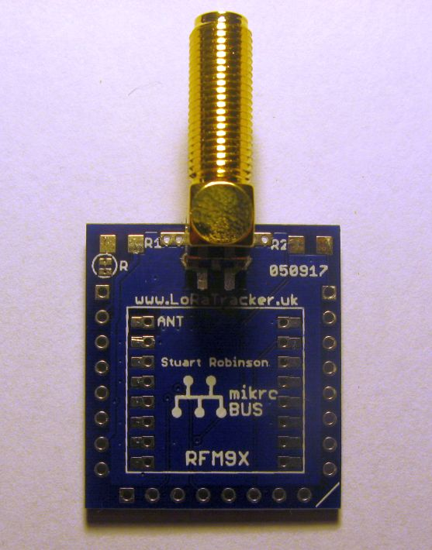
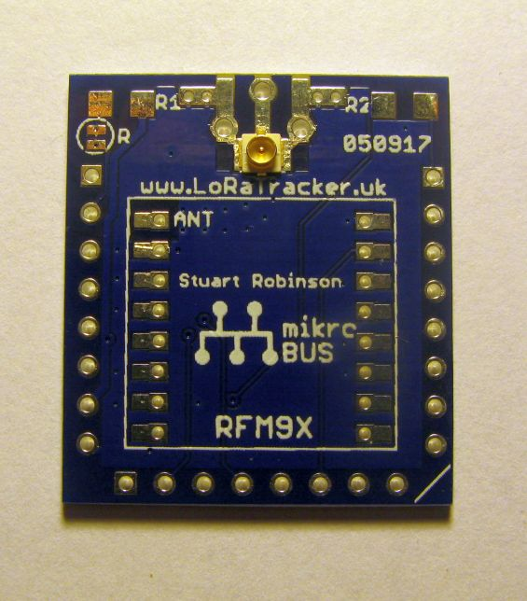

Important: Do not operate the LoRa device without an antenna the LoRa device can easily be damaged in this way.

Testing the LoRa module

Load the LoRa test program, ‘LoRa_Module_Test’ but do not plug a LoRa device into Mikrobus socket 1 yet. When the test program initially runs there will be a few short LED flashes, then the program will check for the presence of the LoRa device (which is not plugged in of course) and so the LED will flash very rapidly, indicating the error. Turn off the power (remove the program lead).

Plug in a LoRa Mikrobus device into Socket 1, make sure an antenna is fitted

Plug in LoRa device and connect the power again. The initial short LED flash should be followed by the LED being continuously on for about 2.5 seconds. If you have a UHF hand-held receiver tuned to 434.4mHz, you should hear an audio tone. The Arduino IDE serial monitor output should look like this;

LoRa_Module_Test
V1.0
15/11/2017
Stuart Robinson

LED Flash

Checking LoRa Device - Present
LoRa Registers
Reg 0 1 2 3 4 5 6 7 8 9 A B C D E F
0x00 00 08 1A 0B 00 52 6C 80 00 4F 09 2B 03 08 02 0A
0x10 FF 00 15 0B 28 0C 12 47 32 3E 00 00 00 00 00 FF
0x20 00 0C 00 00 05 00 03 93 55 55 55 55 55 55 55 55
0x30 90 40 40 00 00 0F 00 00 00 F5 20 82 FD 02 00 40
0x40 00 00 12 24 2D 00 03 00 04 23 00 09 05 84 32 2B
0x50 14 00 00 12 00 00 00 0F E0 00 0C 00 07 00 5C 78
0x60 00 19 0C 4B CC 0E 41 20 04 47 AF 3F E7 3F 77 0B
0x70 D0 01 10 00 00 00 00 00 00 00 00 00 00 00 00 00
Transmit FM Tone - Done

Note the 6C 80 00 on the first line of LoRa registers printed out. These 3 registers indicate the frequency in 61.03515625 hertz steps. Hexadecimal 6C8000 = decimal 7110656 and 7110656 x 61.03515625 is 434400000hz.

We do now have the receiver board working and if all you wanted was to build was a very basic receiver that you could use with a serial console then you are done. There is a version of the Receiver1 software that just requires a serial console to use it and this version is the one that provides remote control to the remote tracker. If your stopping construction here, it is still worth fitting the I2C FRAM, see later notes.

Assuming we are going to build a complete receiver with GPS and display we will continue.

You can remove the LoRa module for now.

Building the GPS Mikrobus module

This Mikrobus board was designed to serve two functions, first to allow a range of GPS modules to be used as a plug in GPS module for the LoRaTracker receivers.

There is a series of pin headers, GPS1 to GPS4, that match some of the common GPS modules. You can just simply solder an angled 0.1” pin header in place and connect the GPS by a cable. The option for some GPS modules is to fix the module direct to the PCB, so the choice is yours.

The second function was to provide a general purpose module to which a range of external devices can be connected. You can connect I2C sensors, a real time clock or and Atmel programming header (ICSP). Further details will be found in the Mikrobus part of the LoRaTracker repository on Git Hub.

Assembling a Global Top GPS module

The Global Top GPSs are available on a PCB and this can be fixed direct to the Mikrobus PCB using a 6 pin 0.1” header in G3, see picture below. Add a few blobs of hot melt glue on the ends to avoid putting pressure on the connections if you push down on the GPS.

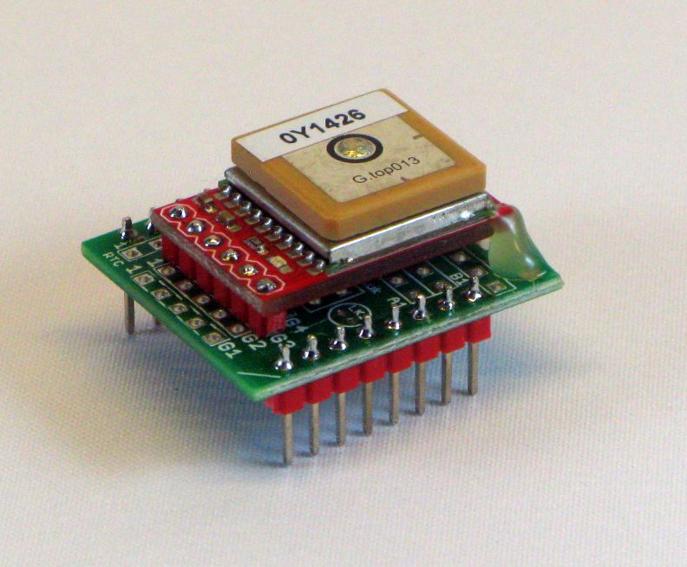

Assembling a Ublox GPS module

The Ublox modules with a large 25mm ceramic antenna are available at low cost and the antenna results in good strong GPS signals. You can fit one of these GPS onto the Mikrobus PCB. This makes a plug in module that works well with the LCD portable receiver, and despite the fact that GPS antenna is slightly obscured by the LCD display it works well.

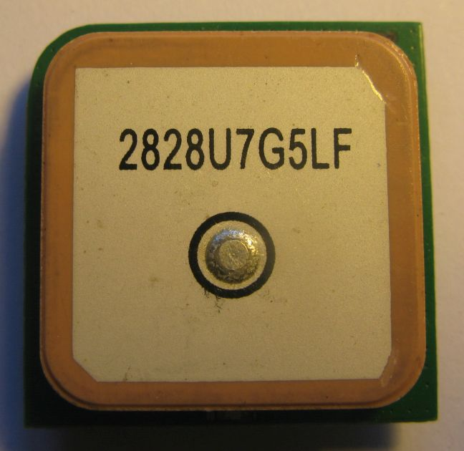
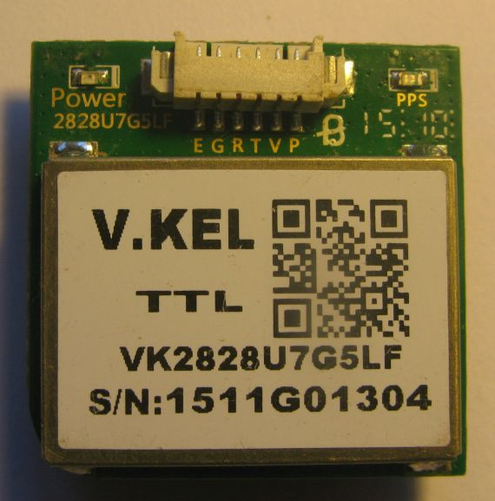

First push the 2 rows of 8 way 0.1” pin headers through the holes in the PCB, and trim them flush with a pair of sharp wire cutters. See picture below.

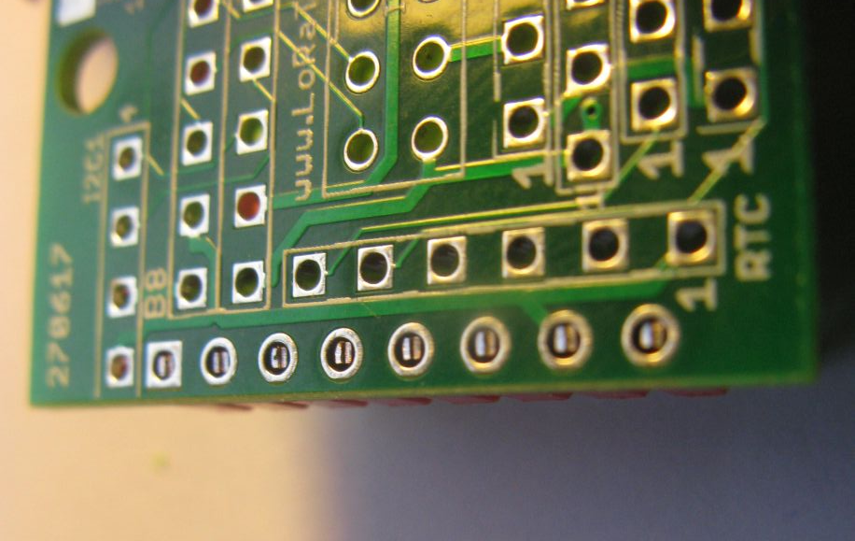

Making sure the pins are straight solder the pins in place, you should be left with joints that are small blobs of solder only slightly proud of the PCB.

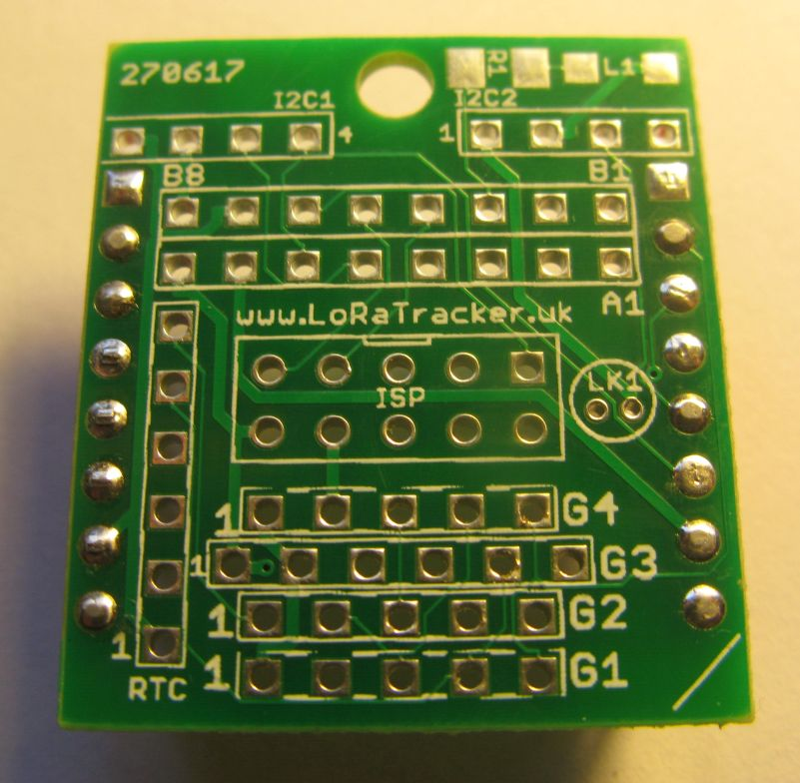

Put two layers of thick double sided adhesive tape on the metal (the label) part of the GPSs underside. Thread the wires from the GPSs connector through the large hole at the top of the Mikrobus PCB. Stick the GPS in place centrally on the Mikrobus PCB.

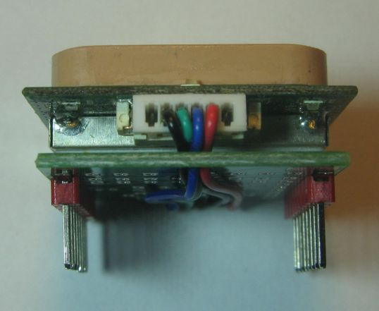
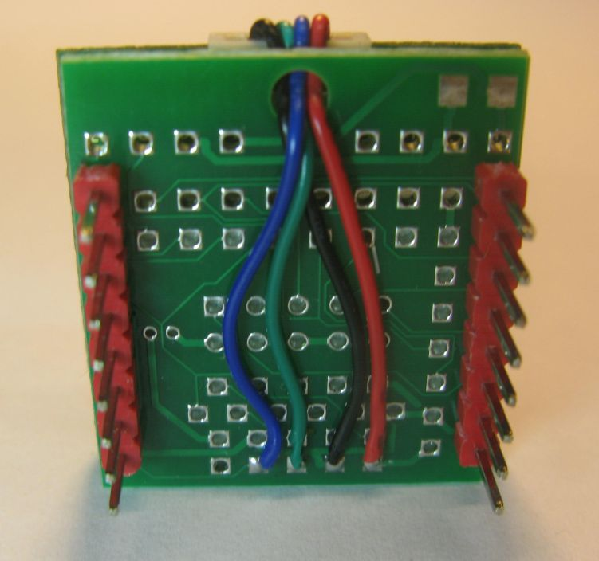
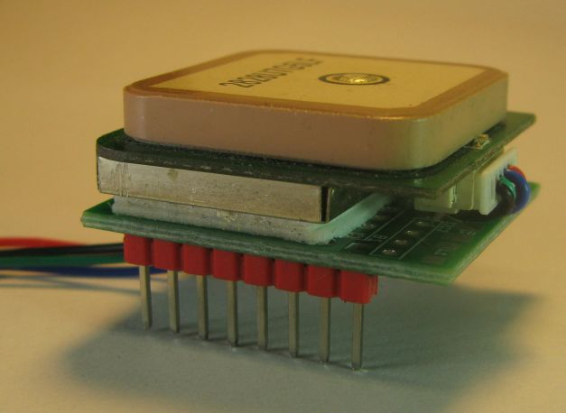

Bend the wires over underneath the Mikrobus PCB and solder in place. Shown in the picture above is the GPS connected to G1.
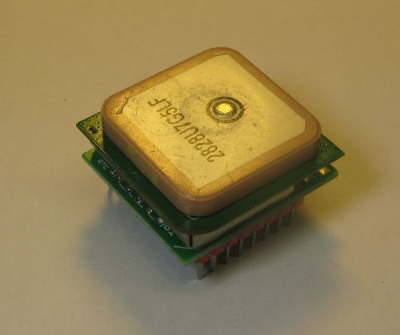

Adding the Battery
Up till this point in the build the power supply coming from the USB Serial programming lead may have been able to supply enough current to power the receiver, but its likely it will not supply enough current to run the GPS.

So at this point you need to fit the components to connect the battery.

Solder in place the 2 pin battery connector, SW3, D1, C3, C4 and the polyfuse FS1.

This should feed the battery power to the RAW pin (power input) on the Pro Mini. Note that C3 and C4 are supplied in the Mini Kit as non-polarity electrolytics, you can fit them either way around.

The recommended power supply is 4 x AA alkaline batteries. It might be though that 3 x AA alkaline is enough for a battery that is often thought of as providing 1.5V. However typical alkaline batteries can be down to 1.2V each when only half discharged so 3 would only provide 3.6V to the receiver which is marginal. You can use 4 x AA NiMh rechargeable batteries as an alternative. So use 4 batteries for now.
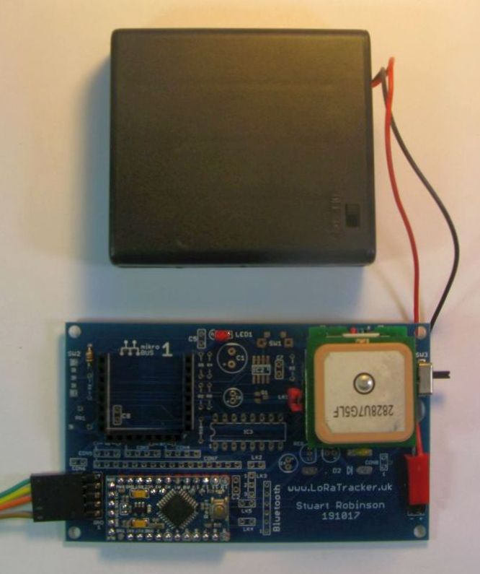

Testing the GPS
Now is the time to use a 4 pin lead between the programming adapter and the receiver board, this is the lead with the VCC power lead missing, see the discussion on serial adapters at the beginning of these instructions.

Fit LK1

The Mikrobus socket intended for the GPS can have components fitted that can remove the power from the socket. We are not fitting these at the moment, so fit LK1. I chose to fit a 2 pin 0.1” header and jumper, its the red link in the picture above of the receiver board with battery .

Make sure you have downloaded and installed the NeoSWSerial library from here;

https://github.com/SlashDevin/NeoSWSerial

Plug a GPS module into Mikrobus socket 2 and load the ‘EchoGPS_Softwareserial_Test’ program and let it run. You can connect a GPS direct to the receiver PCB by fitting an angled 6 way 0.1” pin header to CONGPS, which is underneath Mikrobus socket 2.

The serial monitor output should look something like this;

EchoGPS_Serial_Test
V1.0
151117
Stuart Robinson
GPSOn
$GPRMC,,V,,,,,,,,,,N*53
$GPVTG,,,,,,,,,N*30
$GPGGA,,,,,,0,00,99.99,,,,,,*48
$GPGSA,A,1,,,,,,,,,,,,,99.99,99.99,99.99*30

If you see something like this;

EchoGPS_Serial_Test
V1.0
151117
Stuart Robinson
GPSOn
$GNRMC,,V,,,,,,,,,,N*4D
$GNVTG,,,,,,,,,N*2E
$GNGGA,,,,,,0,00,99.99,,,,,,*56
$GNGSA,A,1,,,,,,,,,,,,,99.99,99.99,99.99*2

Note the all the $GP have been replaced with $GN then you have probably have a Ublox GPS. You will need to set Ublox GPS in the settings file when loading the full receiver programs.

Adding the LCD Display

There are two options for adding the 20x4 LCD. First you can buy an LCD I2C backpack. They are very low cost and found on eBay for instance. This backpack is designed to solder onto the back of the LCD display and there is then a 4 pin header to connect to the driving project. Unfortunately the 4 pin header is often fitted so that it pokes out over the edge of the display. For our finished receiver we need the header to be around the other way and then underneath the PCB, see the as supplied backpack (left) and as required (right) photographs.

Both the LCD I2C backpack and the LCD receiver board itself use a PCF8574 I2C I\O expander to drive the display itself.
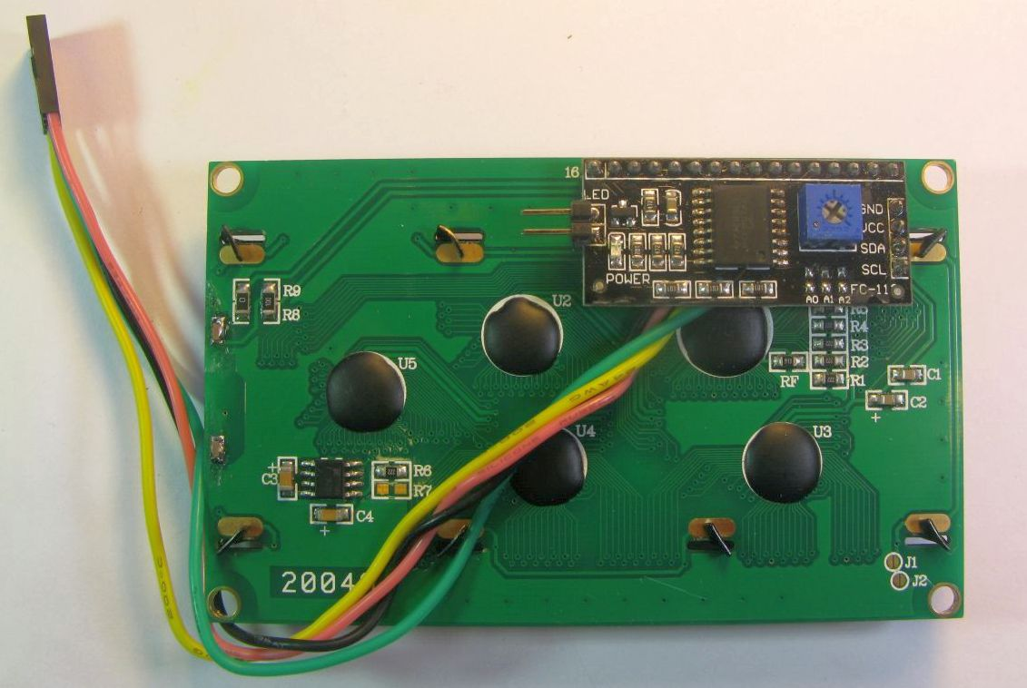

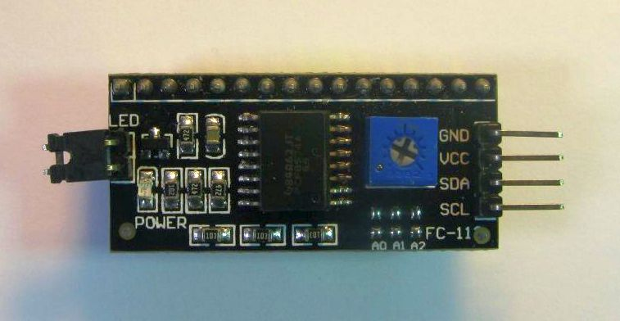

If your using the pre assembled backpack, then there is room between the receiver and the LoRa module (just). The 4 pin lead from the I2C backpack fit into CON4 on the receiver PCB. Be sure to check the wiring against the circuit diagram.

If your going to use the receivers on-board components to drive the display then continue below, otherwise skip to ‘Testing the LCD Display’

Solder in place the first of the LCD driver components, IC3 (PCF8574), R6, R7 and R10.

Solder in place PR1, SW2, R9, CON6 and CON7.

Fit a 0.1” x 16way angled connector to the LCD display with the pin ends pointing downwards, see the next below.

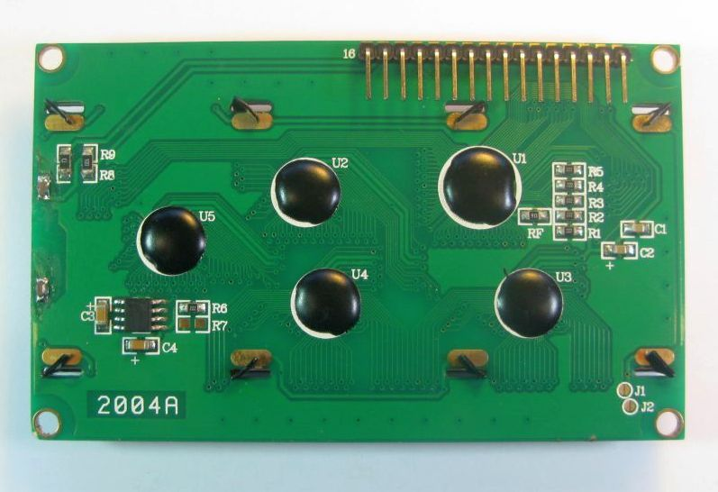

Note: If your making a slimline version of the receiver, 10mm thinner than the standard one (and using 5mm spacers) then you will have to solder the wires for the LCD display direct into the holes of CON7, there is not room for a vertical pin and socket arrangement.

Connect the display with a 16 way 0.1” cable from CON7 to the angled connector fitted to the LCD display, see picture. You actually only need 12 of the 16 connections.

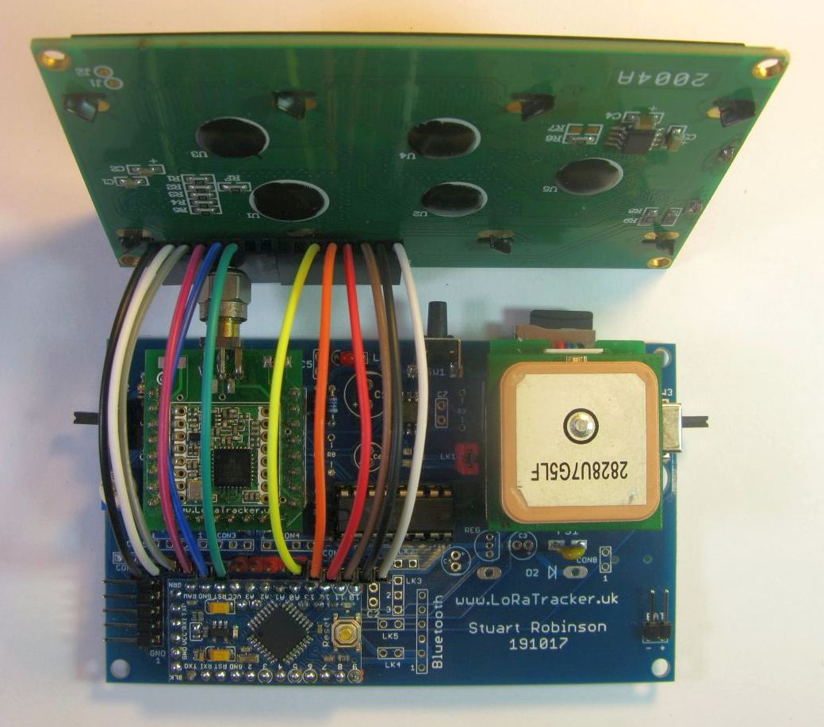

The picture above shows the receiver with the PCF8574 and all associated components required to drive the LCD direct, I used a DIL socket for the PCF8574.

Testing the LCD Display

Load and run the ‘I2C_Scanner_Test’. The serial monitor should report a device found on address 0x3F as below;

I2C_Scanner
V1.2
15/11/2017
Stuart Robinson

I2C Scanner
Scanning for I2C devices...
I2C device found at address 0x3F
done

Unfortunately there are different versions of the PCF8574 in use, so the address shown by the I2C scanner in the above test might be different, I have seen values of 0x27 and 0x3F. The value detected above needs to match the value used in the LCD test program and the receiver program itself.

Once the components are assembled, or an LCD with its own backpack is plugged into CON4, load the ‘I2C_20x4_LCD_Test’ program and check that the PCF8574 address specified by this line at the top of the program matches the I2C address detected above;

#define PCF8574Address 0x3F

Load the program and the first screen on the display should look like this;

LoRaTracker.uk
I2C LCD Backpack
0123456789ABCDEFGHIJ
Last Line of Text

You probably need to adjust the contrast control (PR1 on the LCD receiver PCB) in order to see tha characters.

The display alternates between the above and a sample screen showing an example of the completed receivers display.

In the portable receiver program the PCF8574 address is defined by this line in the settings file;

#define PCF8574Address 0x3F

I2C FRAM

Some of the receiver programs, the portable receiver in particular, require non-volatile memory for storing the last received GPS co-ordinates from a tracker. The EEPROM on the microcontroller is not suitable for this requirement.

Fit IC2 (MB85RC16PNF), make sure pin 1 is on the side nearest to the LED and SW1.

Load the ‘I2C_Scanner_Test ’ program again and run it, the serial monitor should look like this;

I2C Scanner
Scanning for I2C devices...
I2C device found at address 0x3F
I2C device found at address 0x50
I2C device found at address 0x51
I2C device found at address 0x52
I2C device found at address 0x53
I2C device found at address 0x54
I2C device found at address 0x55
I2C device found at address 0x56
I2C device found at address 0x57
done

The FRAM puts each 256byte block at a different I2C address. 0X3F is the address of the I2C display driver in this case.

Load and run the ‘I2C_FRAM_Memory_Test’ program. On the serial monitor it will print the contents of the memory, then start writing a float to the FRAM and reading it back such as;

Writing Memory as 1.247135 Reading Memory as 1.247135 - Memory Errors 0

Press reset on the Pro Mini or remove the power just after a Writing Memory line is printed.

Next time you restart the program, apply the power, the program will report the saved value such as;

Memory at Reset 1.247135

This value should match the value noted at reset or power off.

Screen Switch

SW1 is used by by the receiver programs to switch screens. It should be a long button type if you want the button to be outside a case. Solder the switch in place and load and run the ‘Interrupt_Switch_Test’. When the switch is pressed an interrupt is generated and the receiver LED should light.

Fit SW1

LCD Back light

The LCD has a back light and you can add a switch to turn it on and off.

If your using the receivers on board PCF8574 to drive the LCD then the ribbon cable between the LCD display and receiver board will have picked up the connections for the display back light, so to allow it to be controlled you just need to fit SW2 and R9 to control the LCD back light. R9 can be replaced by a wire link, this will increase back light. current from around 10mA to 33mA.

Fit SW2, R9

If your using an LCD display with the I2C backpack already fitted you will need to fit SW2 and R9 as above plus the 2 pin CON2 and connect links between this jumper and LED pins on the I2C backpack.

Decoupling Capacitors

Fit C2 and C8.

You will probably find that the receiver board is working without these components and The Pro Mini does have its own, but it does not harm to fit these components, just in case. Note that C1 although marked on the PCB is not fitted.

Fitting the Display

The receiver in is basic form is finished, so we can add the display to make the receiver usable as a bench top or portable receiver. You can now secure the 25mm M3 threaded pillars to the receiver PCB with M3 x 5mm screws. Then fit the display to the other end of the pillars. There is a hole in the PCB below the power switch (SW3) to thread the battery connector in from the rear. With the excess soldered trimmed flush from the rear of the PCB you can secure a battery holder or box to the rear of the receiver PCB with some thick double sided tape.

Power Consumption
The measured power consumption of the LCD receiver at power on, with the LCD display connected and back light. on, the GPS running and the LoRa device transmitting a 10dBm FM tone was 130mA.

Receiver Options
There are several options for the receiver board depending on the what you will be using the receiver for. These are discussed below.

Micro SD Card

One of the Receiver programs will log received LoRa packets to a MicroSD card. The drivers for this consume too much memory to allow it to be used with the portable receiver (with GPS) version of the software, but the logger version is useful for unattended operation. Since its battery powered it could be left at a strategic high point to log all received telemetry to SD card.

The micro SD card holder is fitted underneath Mikrobus socket 2, and is easy to retro fit to the receiver PCB if your using the Mikrobus sockets. There is also a connector (CON2) for an external SD card module. Note that if your using the SD card then the chip select on Mikrobus socket 2 is not available and vice versa.

Solder the MicroSD card holder in place

Important: There are two positions for the MicroSD card holder, one projects the MicroSD card upwards 3mm so that the holder would project out of a case, if your fitting one.

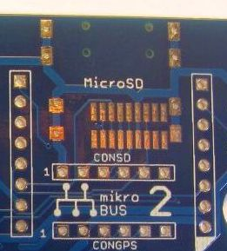

On a formatted MicroSD card copy the text file called ‘textfile.txt’ in SD_Card_Test directory and copy it to the root directory of the MicroSD card. Load the program ‘SD_Card_Test’ and upload it to the receiver board. The serial console should reports the file is found and then print the contents of the file to the serial console.

SD_Card_Test
V1.0
041017
Stuart Robinson
Initializing SD card...Card initialized.
Opening File
# Copyright: Public domain.
# Filename: BURN_BABY_BURN--MASTER_IGNITION_ROUTINE.agc
# Purpose: Part of the source code for Luminary 1A build 099.
# It is part of the source code for the Lunar Module's (LM)
# Apollo Guidance Computer (AGC), for Apollo 11.
# Assembler: yaYUL
# Contact: Ron Burkey <info@sandroid.org>.
# Website: www.ibiblio.org/apollo.
# Pages: 731-751
# Mod history: 2009-05-19 RSB Adapted from the corresponding
# Luminary131 file, using page
# images from Luminary 1A.
# 2009-06-07 RSB Corrected 3 typos.
# 2009-07-23 RSB Added Onno's notes on the naming
# of this function, which he got from
# Don Eyles.
#
# This source code has been transcribed or otherwise adapted from
# digitized images of a hardcopy from the MIT Museum. The digiti

The testfile is part of the source code for the Apollo 11 Lunar Lander navigation and guidance computer.

Low Drop Out Voltage regulator
The voltage regulator on the Pro Mini has its limits, it typically has a drop out voltage of 600mV meaning that it needs a minimum of 3.9V input in order to supply a regulated 3.3V. In addition the Pro Mini’s regulator set-up is not best suited for very low current sleep mode.

To work around these problems you can fit an MCP1700 regulator and associated components. This regulator has a specified drop out voltage of 125mV at 250mA. At a typical receiver power consumption of 125mA, the drop out voltage is around 62mV.

Fit C3, C4 and REG1.

You should remove the regulator on the Pro Mini, its easy to cut off just by slicing through the 5 leads with a sharp blade, see below.
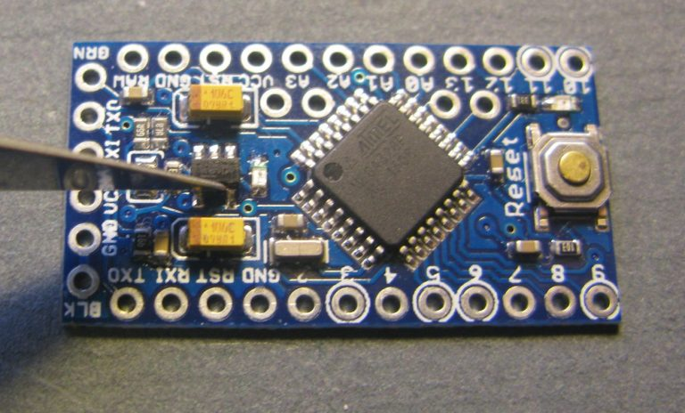

Important: The MCP1700 has a maximum input voltage of 6V, so you need to use it with 3 x AA Alkaline batteries not 4.
When you next power up the receiver the power to the VCC line will come from the MCP1700 on the receiver board.

Voltage Overload Diode
If you want to protect the receiver from a voltage overload, and this applies in particular to using the MCP1700 low drop-out voltage regulator described above, then you can fit D2. This will together with the polyfuse FS1, limit the maximum input voltage to around 5.6V.

Fit D2

GPS Power down
You can fit components that will allow the GPS to be powered down, this can significantly reduce power consumption in some applications. If the GPS has a battery backup, then it will likely reacquire a fix within a few seconds of being powered back up.

Fit C6, C7, R2, R3 and Q1. Remove link LK1 if previously fitted.

The receiver software assumes that the GPS Power down option is always fitted so no program changes are required when this option is added.

Bluetooth Adapter
You can fit a HC06 Bluetooth adapter in place with 0.1” pin headers on the PCB.
Fit a HC06, add LK4.

There are a series of links required to patch the Bluetooth HC06 adapter into the receivers circuit. The first is LK4 which connects the power to the HC06. There is a link here so that at a later point you can remove the power from the HC06.

There is a link to be selected for the RX data pin on the HC06 module. There are not enough pins on the Pro Mini to allow for a unique connections for HC06 so you have to decide if you want the HC06 to use the serial pin from Mikrobus socket 1 or 2. If you have a LoRa module in Mikrobus socket 1 and a GPS in 2, then you would want to link pins 1 and 2 of LK3. None of the LoRaTracker receiver programs receive data from the HC06, but you can connect this pin if required, add a link for LK5.

You can now download one of the Receiver1 programs and load it into the receiver. There are instructions about configuring and using the various receiver programs in the repository;

https://github.com/LoRaTracker/Receiver1

All done.

Stuart Robinson
November 2017

